# Index.html

<!DOCTYPE html>

<html lang="en">

<head>

    <meta charset="UTF-8">

    <meta name="viewport" content="width=device-width, initial-scale=1.0">

    <title>Document</title>

    <link rel="stylesheet" href="style.css">

    <link rel="preconnect" href="https://fonts.googleapis.com">

<link rel="preconnect" href="https://fonts.gstatic.com" crossorigin>

<link href="https://fonts.googleapis.com/css2?family=Poppins:ital,wght@0,100;0,200;0,300;0,400;0,500;0,600;0,700;0,800;0,900;1,100;1,200;1,300;1,400;1,500;1,600;1,700;1,800;1,900&display=swap" rel="stylesheet">

<link rel="stylesheet" href="https://cdnjs.cloudflare.com/ajax/libs/font-awesome/6.6.0/css/all.min.css">

</head>

<body>

    <!-- header section starts -->

    <div class="nav-bar">

        <h3>Home</h3>

        <ul>

            <li><a href="#">Home</a</li>

            <li><a href="#about-me">About Me</a></li>

            <li><a href="projects.html">projects</a></li>

            <li><a href="#contact">Contact</a></li>

        </ul>

    </div>

    <!-- header section end -->

    <!-- body section starts -->

     <div class="home-box1">

        <div class="home-box1-image">

            <img src="images/profile.jpg" alt="profile picture">

        </div>

        <div class="home-box1-p">

            <p>

                I'am <br>

                Hasindu liyanage

            </p>

        </div>

     </div>

     <div class="about-me" align="center" id="about-me">

        <h1>About me</h1>

        <p>

            Welcome to my portfolio! I’m Hasindu Shehan, a passionate creative specializing in graphic design and digital media. With over five years of experience in the industry, I’ve had the privilege of working with diverse clients, from startups to established brands.

        </p>

        <p>

            I thrive on transforming ideas into visually compelling designs that engage and inspire. My expertise includes branding, illustration, and web design, and I’m always eager to explore new trends and techniques to elevate my work.

        </p>

        <p>

            When I’m not designing, you can find me experimenting with photography, hiking in the great outdoors, or sipping coffee at my favorite local café. I believe that creativity knows no bounds, and I’m excited to collaborate on projects that challenge the norm.

        </p>

        <p>

            Feel free to reach out if you’d like to connect or learn more about my work!

        </p>

     </div>

     <div class="skill">

        <table align="center">

            <tr>

                <td>

                    <div class="skill-container">

                        <div>

                            <i class="fa-solid fa-globe"></i>

                        </div>

                        <div>

                            <h3>Full-Stack Development Expertise</h3>

                            <p>Proficient in building comprehensive web applications, from backend logic (Spring Boot, .NET C#) to engaging frontends (React, Node.js), bringing a balanced, full-stack skill set to every project.

                            </p>

                        </div>

                    </div>

                </td>

                <td>

                    <div class="skill-container">

                        <div>

                            <i class="fa-regular fa-lightbulb"></i>

                        </div>

                        <div>

                            <h3>Problem Solving and Analytical Thinking</h3>

                            <p>Strong capability to break down complex problems, analyze solutions from various angles, and develop effective strategies to implement high-quality, innovative solutions.

                            </p>

                        </div>

                    </div>

                </td>

            </tr>

            <tr>

                <td>

                    <div class="skill-container">

                        <div>

                            <i class="fa-solid fa-microchip"></i>

                        </div>

                        <div>

                            <h3>Knowledge of Emerging Technologies</h3>

                            <p>Passionate about staying up-to-date with technology trends, such as AWS for cloud computing, IoT, machine learning, and VR development, leveraging these skills to craft forward-thinking applications.

                            </p>

                        </div>

                    </div>

                </td>

                <td>

                    <div class="skill-container">

                        <div>

                            <i class="fa-solid fa-people-group"></i>

                        </div>

                        <div>

                            <h3>Effective Communication and Team Collaboration</h3>

                            <p>Proven track record in working within diverse teams, with excellent communication skills that make it easy to share ideas, collaborate on projects, and ensure everyone is aligned on goals.

                            </p>

                        </div>

                    </div>

                </td>

            </tr>

        </table>

     </div>

     <div class="contact" id="contact">

        <table align="center" width="100%">

            <tr>

                <td>

                    <div>

                        <h1>Contact Me...</h1>

                        <p>Email : hasindus48@gmail.com<br>

                        phone number : 0765936558</p>

                    </div>

                </td>

                <td>

                    <div>

                        <i class="fa-brands fa-facebook"></i><a href="https://web.facebook.com/hasindu.liyanage.1">facebook.com/hasindu.liyanage.1</a><br><br><br>

                        <i class="fa-brands fa-instagram"></i><a href="https://www.instagram.com/hasindu_liyanage/">instagram.com/hasindu_liyanage</a><br><br><br>

                        <i class="fa-brands fa-linkedin"></i><a href="https://www.linkedin.com/in/hasindu-liyanage-409153220/">linkedin.com/hasindu-liyanage</a>

                    </div>

                </td>

            </tr>

        </table>

     </div>

     <div class="box">

     </div>

</body>

</html>

# Project.html

<!DOCTYPE html>

<html lang="en">

<head>

    <meta charset="UTF-8">

    <meta name="viewport" content="width=device-width, initial-scale=1.0">

    <title>Document</title>

    <link rel="stylesheet" href="style.css">

    <link rel="preconnect" href="https://fonts.googleapis.com">

<link rel="preconnect" href="https://fonts.gstatic.com" crossorigin>

<link href="https://fonts.googleapis.com/css2?family=Poppins:ital,wght@0,100;0,200;0,300;0,400;0,500;0,600;0,700;0,800;0,900;1,100;1,200;1,300;1,400;1,500;1,600;1,700;1,800;1,900&display=swap" rel="stylesheet">

<link rel="stylesheet" href="https://cdnjs.cloudflare.com/ajax/libs/font-awesome/6.6.0/css/all.min.css">

</head>

<body>

    <!-- header section starts -->

    <div class="nav-bar">

        <h3>Projects</h3>

        <ul>

            <li><a href="index.html">Home</a</li>

            <li><a href="projects.html">projects</a></li>

        </ul>

    </div>

    <!-- header section end -->

    <!-- body section starts -->

     <div class="projects">

        <h1 align="center">Project & Achievements</h1>

     <div class="projects-container">

        <div class="Project-imag">

            <img src="images/pos.jpg" alt="" height="100%">

        </div>

        <div class="description">

                <h2>NexaPOS</h2>

                <p>A point-of-sale application developed in .NET C# to manage transactions and inventory efficiently.</p>

                <p><strong>Technologies Used:</strong> .NET C#, SQL Server, Entity Framework</p>

        </div>

     </div>

     <div class="projects-container">

        <div class="Project-imag">

            <img src="images/fitlab.png" alt="" height="100%">

        </div>

        <div class="description">

            <h2>FitLab Gym Website</h2>

            <p>A complete website for a gym with features for users to view information and book training sessions.</p>

            <p><strong>Technologies Used:</strong> HTML, CSS, JavaScript, PHP, MySQL</p>

        </div>

    </div>

    <div class="projects-container">

        <div class="Project-imag">

            <img src="images/netflix.png" alt="" height="100%">

        </div>

        <div class="description">

            <h2>Netflix MVP</h2>

            <p>A minimal viable product for a Netflix-like streaming service, utilizing Spring Boot and Node.js.</p>

            <p><strong>Technologies Used:</strong> Node.js, Spring Boot, MongoDB</p>

        </div>

    </div>

     </div>

     <div class="achievement-container">

        <h1 align="center">Achievements</h1>

        <div class="achievement">

            <p><strong>AWS Cloud Practitioner Certification</strong> <br>Certified in cloud fundamentals, gaining proficiency in AWS services, architecture best practices, and cloud security, enhancing ability to design and deploy applications in the cloud.</p>

        </div>

        <div class="achievement">

            <p><strong>UOK Robobattle 2k24 Participation</strong> <br> Competed in a university-level robotics competition, demonstrating skills in robotics, engineering problem-solving, and teamwork while building and programming a custom robot.</p>

        </div>

        <div class="achievement">

            <p><strong>3D Graphics Project Submission</strong> <br> Successfully completed an advanced assignment involving OpenGL and 3D modeling, culminating in the creation of a realistic virtual reality environment with textures, lighting, and interactive elements.</p>

        </div>

     </div>

     <div class="box">

     </div>

</body>

</html>

## Style.css

body{

    font-family: "Poppins", sans-serif;

    background-color: rgb(244, 244, 244);

}

.nav-bar{

    padding: 20px;

    display: flex;

    text-align: center;

    justify-content: space-between;

}

.nav-bar ul{

    display: flex;

    list-style: none;

}

.nav-bar ul li{

    padding: 0px 10px;

}

.nav-bar ul li a{

    text-decoration: none;

    color: black;

}

/* body section */

.home-box1-image{

    width: 100%;

    height: 100%;

    display: flex;

    justify-content: center;

    align-items: center;

}

.home-box1-image img{

    width: 100%;

    height: 500px;

    object-fit: cover   ;

}

.home-box1{

    display: grid;

    grid-template-columns: auto auto;

    align-items:center;

    justify-content: space-evenly;

    flex-direction: row;

    height: 80vh;

    /* background: linear-gradient(to bottom, #5b37bd, #ffffff); */

}

.home-box1-p{

    width:100%;

    display: flex;

    justify-content: center;

    align-items: center;

}

.home-box1 p{

    font-size: 70px;

    font-weight: bold;

}

.about-me{

    padding: 50px 0px;

    margin: auto;

    max-width: 700px;

}

.about-me p{

letter-spacing: 0.1em;

width: 100%;

}

.about-me h1{

    letter-spacing: 0.1em;

}

.skill-container{

    height: 200px;

    width: 500px;

    background-color: hsl(0, 100%, 99%);

    padding: 20px;

    border-radius: 20px;

    display: flex;

    align-items: center;

}

i{

    font-size: 50px;

}

.skill-container h3,p{

    padding: 0px 20px;

}

table{

    align-items: center;

}

table tr td{

    padding: 20px 20px;

}

.contact{

    max-width: 1120px;

    background-color: hsl(0, 100%, 99%);

    margin: auto;

    border-radius: 20px;

    padding-bottom: 20px;

}

.contact table tr td{

    margin: 100px;

}

.skill i {

    background: linear-gradient(90deg, rgb(128, 0, 128), rgb(255, 105, 180));

    -webkit-background-clip: text;

    -webkit-text-fill-color: transparent;

}

.contact i{

    padding: 0px 20px ;

}

.contact a{

    text-decoration: none;

}

.contact h1{

    padding: 20px 0px 20px 20px;

    font-size: 50px;

}

.box{

height: 100px;

}

.projects-container{

    border: 10px solid rgb(86, 9, 131);

    display: flex;

    align-items: center;

    height: 500px;

    max-width: 1000px;

    background-color: hsl(0, 100%, 99%);

    margin: auto;

    border-radius: 20px;

    margin-top: 50px;

}

.description{

    padding: 20px;

}

.Project-imag{

    width: 400px;

    background-color: bisque;

    height: 100%;

    overflow: hidden;

    border-radius: 20px 0px 0px 20px;

}

.achievement-container{

    padding: 20px;

    margin: 20px;

}

.achievement{

    padding:20px;

    margin-top: 20px;

    background-color: hsl(0, 100%, 99%);

    max-width: 500px;

    margin-left: auto;

    margin-right: auto;

    border-radius: 20px;

}

## Output:

**Home page**

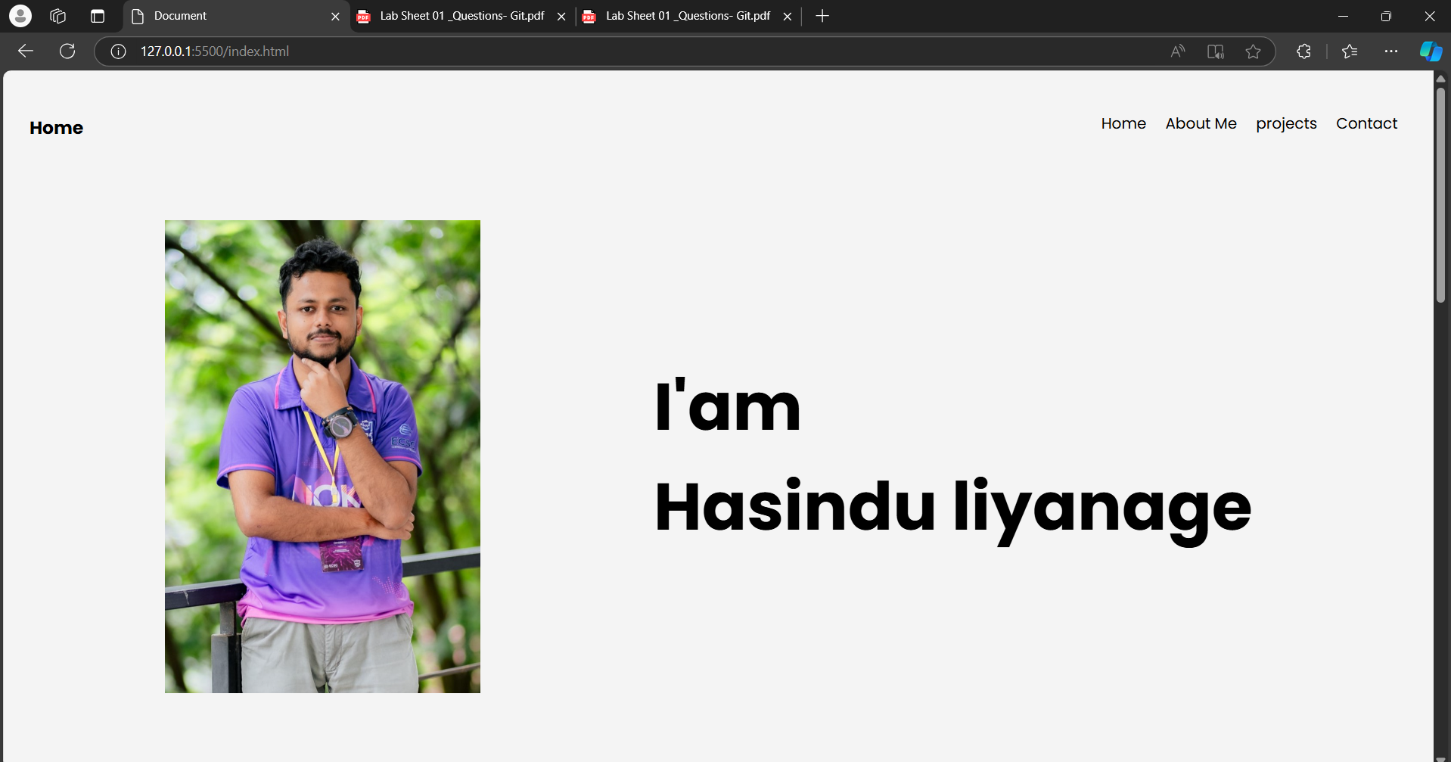

Projects page

# GIT

